**Exercise | Python Data Types**

**Topic:** Python Data Types  
**Time Allotted:** 40 Minutes  
**Objective:** Explore and identify different types of data in Python by creating and editing variable examples.

**🧠 What Are Python Data Types?**

In Python, **data types** are the kind of information you give to a variable. Here are a few examples:

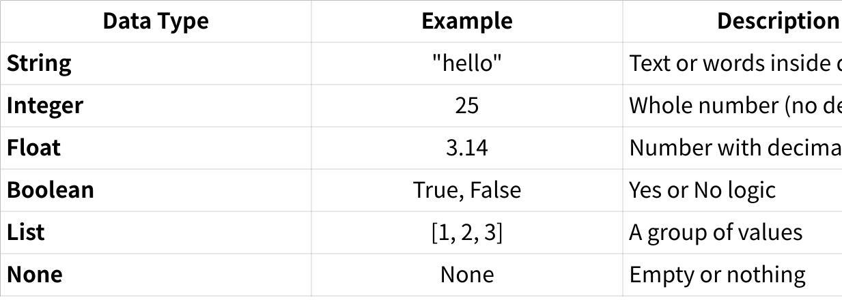

**Click the image to view the sheet.**

**🔍 Instructions:**

You’ll work with a sample Python code that uses different data types. Your task is to explore, change, and create examples using your own information.

You’ll also “test” Python by changing the values and watching how the output changes.

**💻 Sample Code to Edit:**

|  |
| --- |
| Python # Data Type Playground  my_name = "Alex" # String my_age = 20 # Integer my_height = 5.6 # Float is_student = True # Boolean my_favorite_numbers = [7, 11, 23] # List nothing_here = None # None  print("Name:", my_name) print("Age:", my_age) print("Height:", my_height) print("Are you a student?", is_student) print("Favorite numbers:", my_favorite_numbers) print("Nothing here:", nothing_here) |

**🎯 Choose 2–3 Challenges Below:**

🔲 1. Replace all the values with **your own information**  
 🔲 2. Add **2 more data types** (e.g., create a list of colors or use a new boolean)  
 🔲 3. Change is_student to False — what happens?  
 🔲 4. Add a new float (e.g., grade_average = 92.5) and print it  
 🔲 5. Change my_favorite_numbers to a **list of words**

**✏️ Your Updated Code**

# Data Type Playground

my_name = str("Jessie") # String

my_age = int(2) # Integer

my_gwa = float(1.25) # Float

is_student = bool(True) # Boolean

my_fav_animes = ["Naruto", "One Piece", "Detective Conan"] # List

colors = ["Violet", "Red", "Black"] # List

nothing_here = None # None

print("Name:", my_name)

print("Age:", my_age)

print("GWA:", my_gwa)

print("Are you a student?", is_student)

print("Favorite numbers:", my_fav_animes)

print("Favorite Colors:", colors)

print("Nothing here:", nothing_here)

**🖼️ Screenshots**

* Screenshot of your edited code

* A computer screen shot of a program

  AI-generated content may be incorrect.Screenshot of your terminal output

**🤔 Reflection Questions**

1. Which data types did you enjoy using most? Why?
2. What happens when you mixed numbers with text?
3. Why is it useful to check the **type** of a variable?